LAB 2 – CS133

- Perform the describe and info steps
- import pandas as pd

- print(f"Lab 2")

- df = pd.read_csv("Lab 2\housing.csv")

- print(df.head())

- print(df.describe())

- print(df.info())

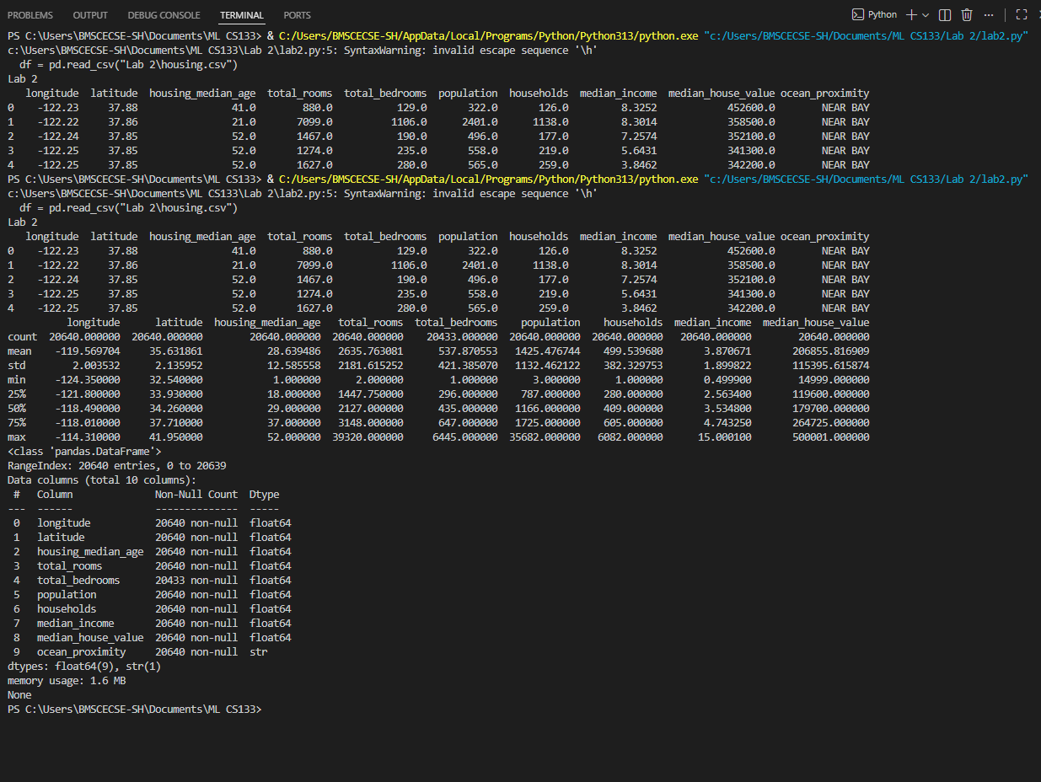

2. Plot the histogram of each feature( Indicate what does histogram
indicate on median_income and house_median_age)
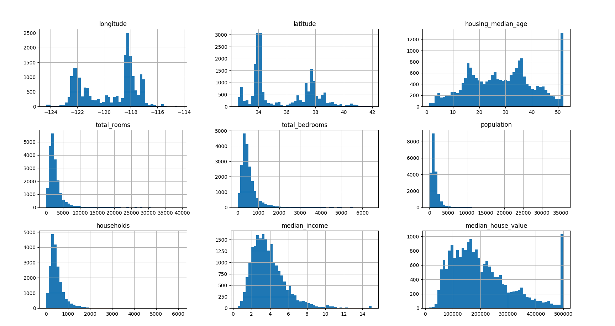

3. Demonstrate the process of creating a test set( write the difference
between random and stratified test set)
from sklearn.model_selection import train_test_split
train_set, test_set = train_test_split(df, test_size=0.2, random_state=42)

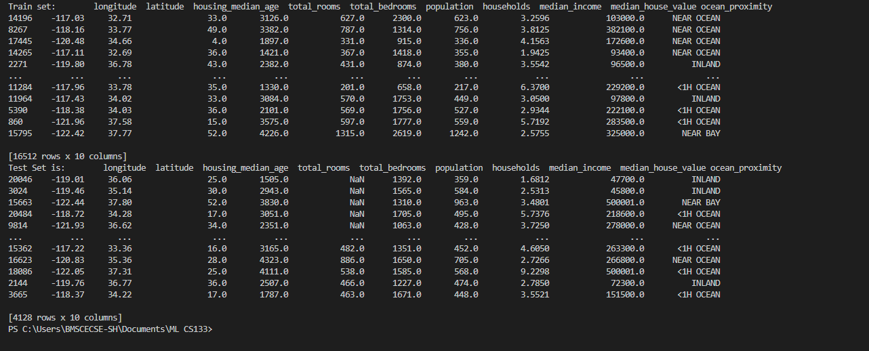

4. List the geographical features from the dataset and plot a graph to
Visualize Geographical Data(what does the graph indicate w.r.t
housing prices and location)
plt.figure(figsize=(10,7))
plt.scatter(df["longitude"], df["latitude"],
c=df["median_house_value"], cmap="jet", alpha=0.4)
plt.colorbar(label="House Price")
plt.xlabel("Longitude")
plt.ylabel("Latitude")
plt.show()
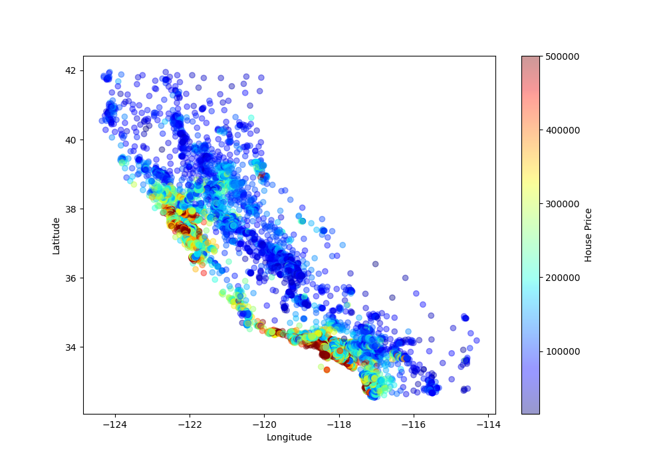

5. Plot a graph to show features correlation with housing price.
Which feature corelates to the maximum. Plot the graph for that
with housing price and analyze what the graph indicate
corr_matrix = df.corr(numeric_only=True)
print(corr_matrix)
corr_matrix["median_house_value"].sort_values(ascending=False)
plt.scatter(df["median_income"], df["median_house_value"], alpha=0.2)
plt.xlabel("Median Income")
plt.ylabel("Median House Value")
plt.show()

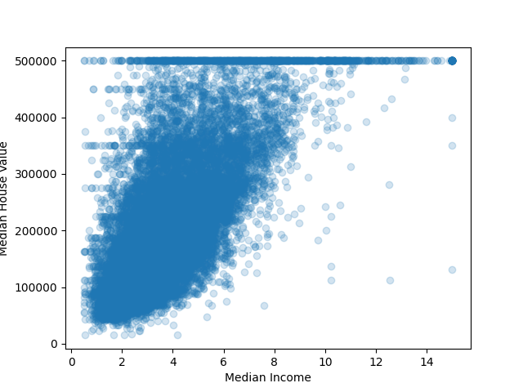

6. List the features that could be combined to improve correlation and
plot again to see if correlation has improved
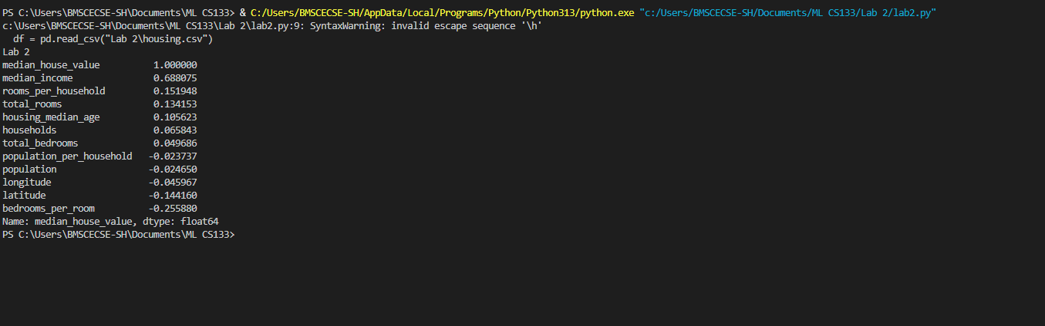
rooms_per_household shows better correlation than total_rooms.

7. List the features that needs to be cleaned and demonstrate the
process of cleaning
print(df.isnull().sum())

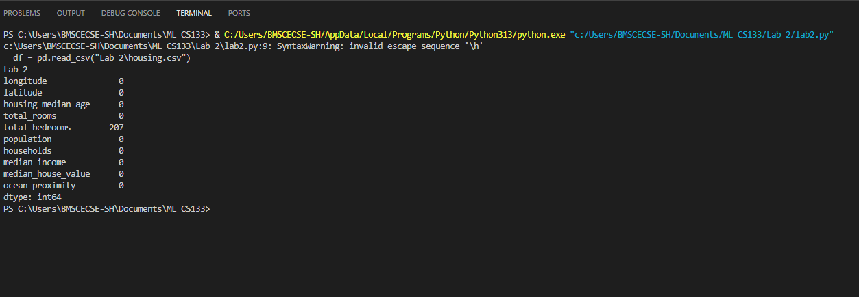

8. Is there any categorical data that needs to be converted to
numerical? If so explain the method used to convert and code the
same and show the output.
from sklearn.preprocessing import OneHotEncoder

encoder = OneHotEncoder(sparse_output=False)
ocean_encoded = encoder.fit_transform(df[["ocean_proximity"]])

encoded_df = pd.DataFrame(ocean_encoded,
columns=encoder.get_feature_names_out())
print(encoded_df.head())

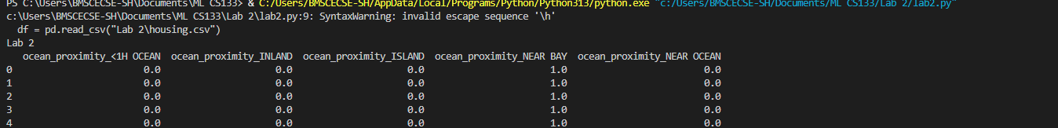

9. Discuss the importance of feature scaling

Why scaling is needed
- Features have different ranges
- Algorithms like:
  - Gradient Descent
  - KNN
  - SVM
perform poorly without scaling

Types
Method | Use Case
Min-Max Scaling | Bounded data
Standardization | Normal-like data (preferred)
10. Design a pipeline inculcating (Custom transform, feature scaling and encoding). Explain how it works.
import pandas as pd
import numpy as np

from sklearn.pipeline import Pipeline
from sklearn.preprocessing import StandardScaler, OneHotEncoder
from sklearn.compose import ColumnTransformer
from sklearn.impute import SimpleImputer
from sklearn.base import BaseEstimator, TransformerMixin

print("Lab 2 - Q10")

# Load dataset (FIXED PATH)
df = pd.read_csv(r"Lab 2\housing.csv")

# Separate features
housing = df.drop("median_house_value", axis=1)

# -------------------------------
# CUSTOM TRANSFORMER
# -------------------------------
class CombinedAttributesAdder(BaseEstimator, TransformerMixin):
def fit(self, X, y=None):
return self

def transform(self, X):
rooms_per_household = X[:, 3] / X[:, 6]
population_per_household = X[:, 5] / X[:, 6]
bedrooms_per_room = X[:, 4] / X[:, 3]
return np.c_[X, rooms_per_household, population_per_household, bedrooms_per_room]

# Separate numerical & categorical attributes
num_attribs = housing.select_dtypes(include=["int64", "float64"]).columns
cat_attribs = ["ocean_proximity"]

# Numerical pipeline
num_pipeline = Pipeline([
("imputer", SimpleImputer(strategy="median")),
("attribs_adder", CombinedAttributesAdder()),
("scaler", StandardScaler())
])

# Full pipeline
full_pipeline = ColumnTransformer([
("num", num_pipeline, num_attribs),
("cat", OneHotEncoder(), cat_attribs)
])

# Apply pipeline
housing_prepared = full_pipeline.fit_transform(housing)

print("Final shape of processed data:")
print(housing_prepared.shape)

